UNITED STATES
SECURITIES AND EXCHANGE COMMISSION
Washington, D.C. 20549
SCHEDULE 14A
Proxy Statement Pursuant to Section 14(a) of the
Securities Exchange Act of 1934
(Amendment No. )
Filed by the Registrant ☒
Filed by a Party other than the Registrant ☐
Check the appropriate box:

☐ | Preliminary Proxy Statement

☐ | Confidential, for Use of the Commission Only as permitted by Rule 14a-6(e)(2))

☐ | Definitive Proxy Statement

☒ | Definitive Additional Materials

☐ | Soliciting Material Pursuant to § 240.14a-12
STERIS plc
(Name of Registrant as Specified in its Charter)
(Name of Person(s) Filing Proxy Statement, if other than the Registrant)
Payment of Filing Fee (Check all boxes that apply):

☒ | No fee required.

☐ | Fee paid previously with preliminary materials.

☐ | Fee computed on table in exhibit required by Item 25(b) per Exchange Act Rules 14a-6(i)(l) and 0-11.

 |  |  |  | Your Vote Counts!
 |  |  |  | STERIS plc  2026 Annual General Meeting  Vote by 4:59 a.m. Irish Standard Time on Thursday, July 30, 2026 (11:59 p.m. Eastern Daylight Time on Wednesday, July 29, 2026). For shares held in the STERIS Corporation 401(K) Plan, vote by 4:59 a.m. Irish Standard Time on Sunday, July 26, 2026 (11:59 p.m. Eastern Daylight Time on Saturday, July 25, 2026)
 |  |  |  | 
STERIS plc

70 SIR JOHN ROGERSON’S QUAY

DUBLIN 2, IRELAND

(COMPANY NUMBER 595593)

T00536-P54079-Z93081

You invested in STERIS plc and it’s time to vote!
You have the right to vote on proposals being presented at the Annual General Meeting. This is an important notice regarding the availability of proxy materials for the shareholder meeting to be held on July 31, 2026.
Get informed before you vote
View the Notice and Proxy Statement, Fiscal 2026 Annual Report, and Directors’ Report and Consolidated Financial Statements for the Year Ending March 31, 2026 online OR you can receive a free paper or email copy of the material by requesting prior to July 17, 2026. If you would like to request a copy of the material for this and/or future shareholder meetings, you may (1) visit www.ProxyVote.com, (2) call 1-800-579-1639 or (3) send an email to sendmaterial@proxyvote.com. If sending an email, please include your control number (indicated below) in the subject line. Unless requested, you will not otherwise receive a paper or email copy.

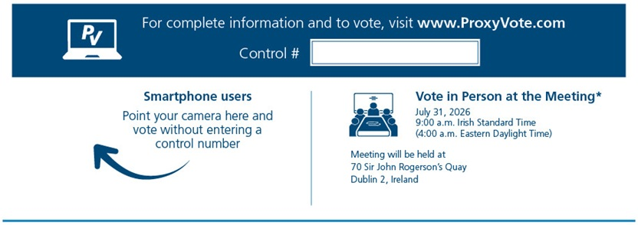
*Please check the meeting materials for any special requirements for meeting attendance and instructions on how to request directions to the meeting. At the meeting, you will need to request a ballot to vote these shares.

Vote at www.ProxyVote.com

THIS IS NOT A VOTABLE BALLOT

This is an overview of the proposals being presented at the upcoming shareholder meeting. Please follow the instructions on the reverse side to vote these important matters.

Voting Items |  |  |  | Board  Recommends
1. |  | Election of Directors
 |  | Nominees:
1a. |  | Dr. Esther M. Alegria |  | For
1b. |  | Pierre Boulud |  | For
1c. |  | Daniel A. Carestio |  | For
1d. |  | Cynthia L. Feldmann |  | For
1e. |  | Christopher S. Holland |  | For
1f. |  | Paul E. Martin |  | For
1g. |  | Dr. Nirav R. Shah |  | For
1h. |  | Louis A. Shapiro |  | For
1i. |  | Dr. Mohsen M. Sohi |  | For
2. |  | To ratify the appointment of Ernst & Young LLP as the Company’s independent registered public accounting firm for the year ending March 31, 2027. |  | For
3. |  | To appoint Ernst & Young Chartered Accountants as the Company’s statutory auditor under Irish law to hold office until the conclusion of the Company’s next annual general meeting. |  | For
4. |  | To authorize the Board of Directors of the Company or the Audit Committee of the Board of Directors to determine the remuneration of Ernst & Young Chartered Accountants as the Company’s statutory auditor under Irish law. |  | For
5. |  | To approve, on a non-binding advisory basis, the compensation of the Company’s named executive officers as disclosed pursuant to the disclosure rules of the U.S. Securities and Exchange Commission, including the compensation discussion and analysis and the tabular and narrative disclosure contained in the Company’s proxy statement dated June 11, 2026. |  | For
6. |  | To approve a proposal renewing the Board of Directors’ authority to issue shares under Irish law. |  | For
7. |  | To approve a proposal renewing the Board of Directors’ authority to opt-out of statutory pre-emption rights under Irish law. |  | For
8. |  | To transact such other business as may properly come before the meeting or any adjournment or postponement thereof.

Prefer to receive an email instead? While voting on www.ProxyVote.com, be sure to click “Delivery Settings”.

T00537-P54079-Z93081

